PIN (Part 1)

Set-up:
There are minimum 3 pieces staying on the same line (files, ranks or diagonals) with the last 2 belongs to one side. The set-up is as follow:

Pinning piece Pinned piece Target
(Queen, Rook, Bishop) (Loose piece, hanging piece)
(High value pieces like Queen)

2- Action:
- Attack the pinned piece by a lesser piece (usually pawns) to win it or the target (see games 1, 2, 4).
- Capture the piece which is defended by the pinned piece to gain material advantage (see game 3).

3-Goal:
To win the target or material.

4-Examples:
In the following games we shall examine how to execute the pin in practice.
Game 1:

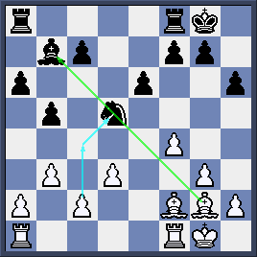
Black Bishop at b7 is unprotected so White plays 1.c4 attacking the pinned Knight at d5.

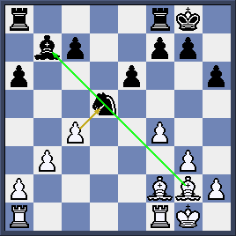
After 1…bxc4 2.dxc4 restoring the pin, White wins either black Knight or black Bishop (if the Knight runs) in the next move.

Game 2:

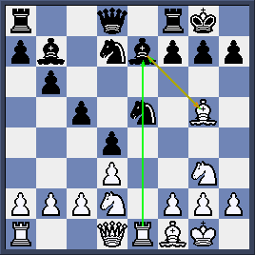
Black has just played 1…Nfd7 to offer Bishop Exchange. That turns out to be a grave mistake.

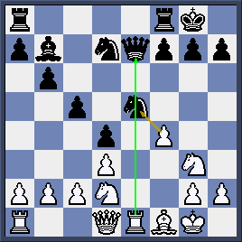
White responds 2.Bxe7 Qxe7 and then nets the pinned Ne5 by 3.f4!

Game 3:
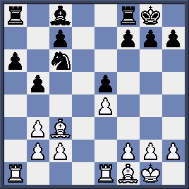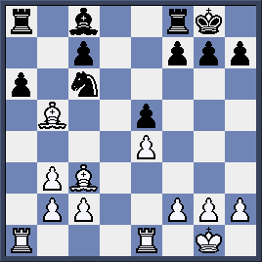
Black Rook at a8 is unprotected so Black pawn a6 is pinned on a-file (diagram 3a). White exploits this fact by taking the pawn 1. Bxb5! (diagram 3b)
Game 4:

White is controlling the center well and is pinning Nf6. He need to push e5 to attack the pinned Knight (diagram 4a).
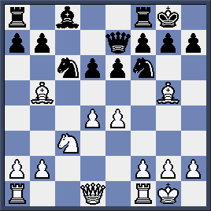

- Bxc6! bxc6 2. e5 dxe5 3.dxe5 White seems to get the piece (diagram 4b).
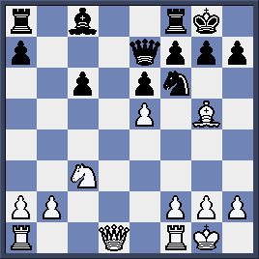

However, Black counter-attacks with another pin!
3… Qc5! (diagram 4c)

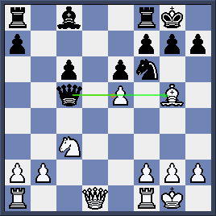
Black avoids the loss of the piece but not his pawn

.

4. Bxf6 gxf6 5. Qg4+! Kh8 6. exf6 (threatening Qg7 checkmates) Rg8 7.Qf4 +/- (diagram 4d)
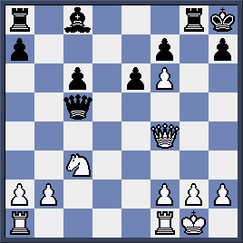

Quizzes:
Whites moves and wins material in the following 4 games.
